* The Vapor Compression Refrigeration Cycle involves four components: compressor, condenser, expansion valve/throttle valve and evaporator. Circulating refrigerant enters the compressor as saturated vapor and is compressed this results in high pressure which in turn is responsible for higher temperature. The compressed vapor then comes out as superheated vapor and attains a temperature and pressure at which condensation can take place with the help of cooling water or cooling air. That hot vapor is passed through a condenser where it is cooled and condensed. This is liquid refrigerant known as saturated liquid is next passed through an expansion valve where there is a sudden drop in pressure. This results in the adiabatic flash evaporation of the liquid refrigerant. As it is called lowers the temperature of the liquid and vapor refrigerant mixture which makes it colder than the temperature to be achieved The cold mixture is passed through the coils in the evaporator. A fan circulates the warm air in the enclosed space where the circulating refrigerant rejects heat from the system. The condensed across the coils carrying the cold refrigerant liquid and vapor mixture. That warm air evaporates the liquid part of the cold refrigerant and at the same time, the circulating air is cooled and as a result it lowers the temperature of the enclosed space to the temperature to be achieved. The circulating refrigerant absorbs and removes heat from the evaporator (cover by a cylindrical plate) which is then rejected in the condenser and transferred by the water or air used in the condenser. For the completion of the refrigeration cycle, the refrigerant vapor coming out of the evaporator

which is again a saturated vapor is returned back.

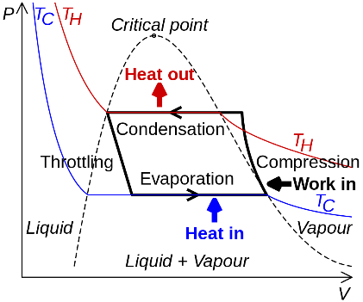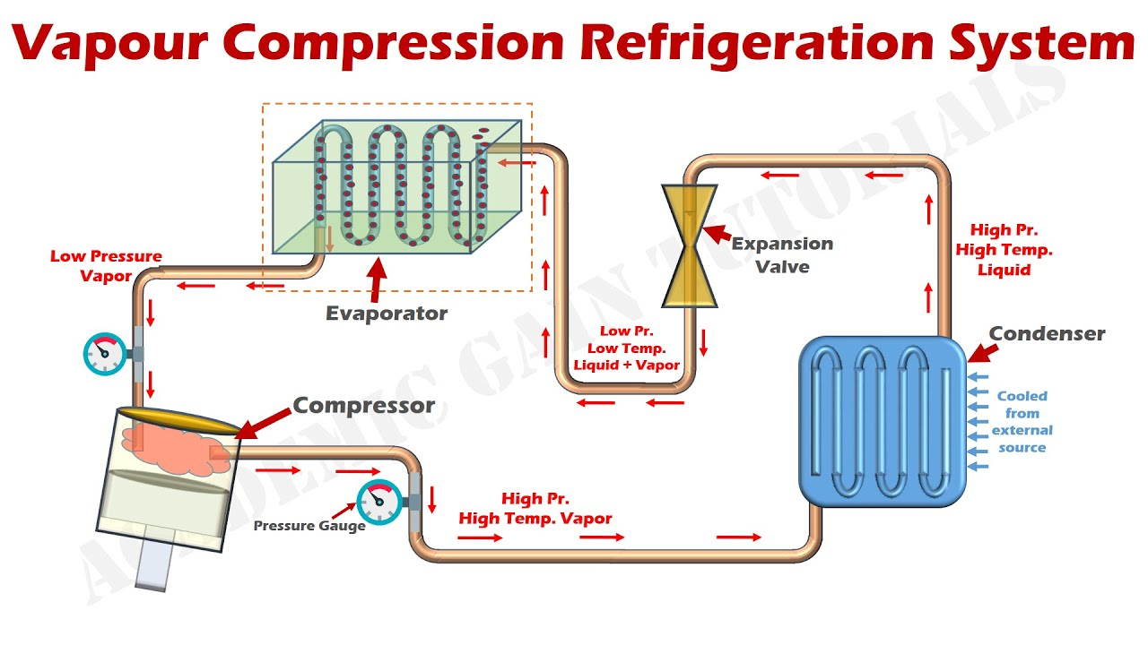

* https://www.youtube.com/watch?v=PjcdqAkP0UA
* Current small-scale prototype can produce a cup of water a day in desert-like humidity conditions
* Operates in almost all humidity conditions
* Demonstrates very high efficiency of water production
* Can be scaled, from household to commercial scale
* Established supply chain for the material at the heart of the device
* Provisional patent filed for the prototype.
* Calculations :  
  First we have calculate dew point temperature (at which vapor start condense) at different DBT (dry bulb temperature) and different relative humidity.

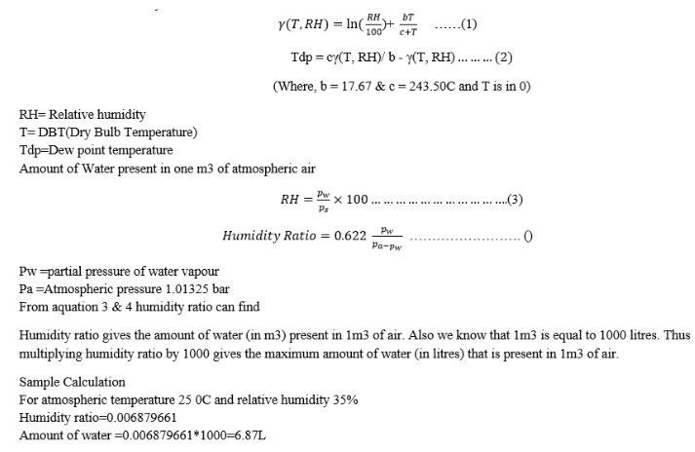

* if ambient temperature is 35 OC or higher and if relative humidity is greater than 50% then the device will function well and it will start condensing water.